ASSIGNMENT 1
Title : Study and implement various networking commands on terminal.

Name : Saumya Dhorje

Roll No : 18
DIV : B AIDS

- IPCONFIG : is a command used in the command prompt to display the IP address and network configuration details of your computer.
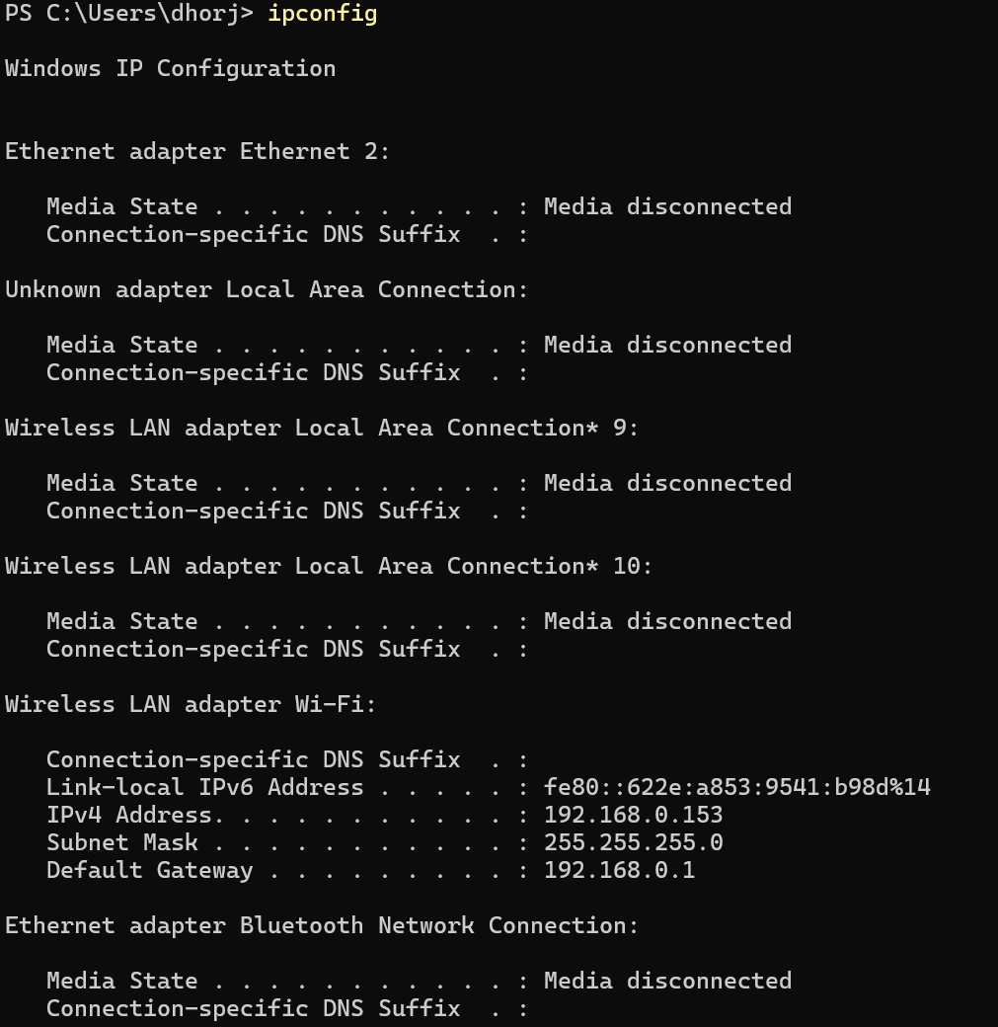

- NSLOOKUP : A command used to find the IP address of a website using its domain name.

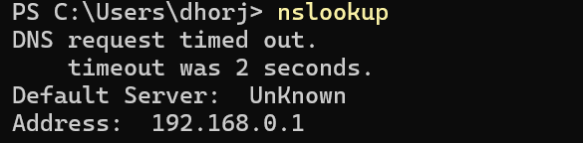

- HOSTNAME : A command used to display the name of the current computer on the network.



- PING : A command used to check whether a computer or website is reachable on the network.
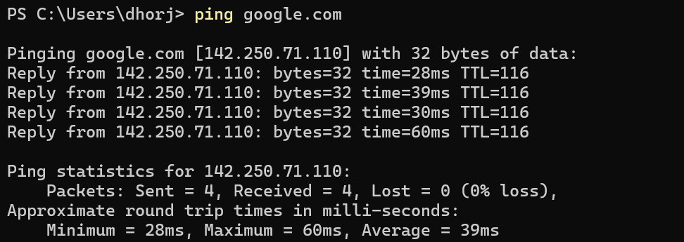

- TRACERT : A command used to show the path taken by data packets from your computer to another device on the network.
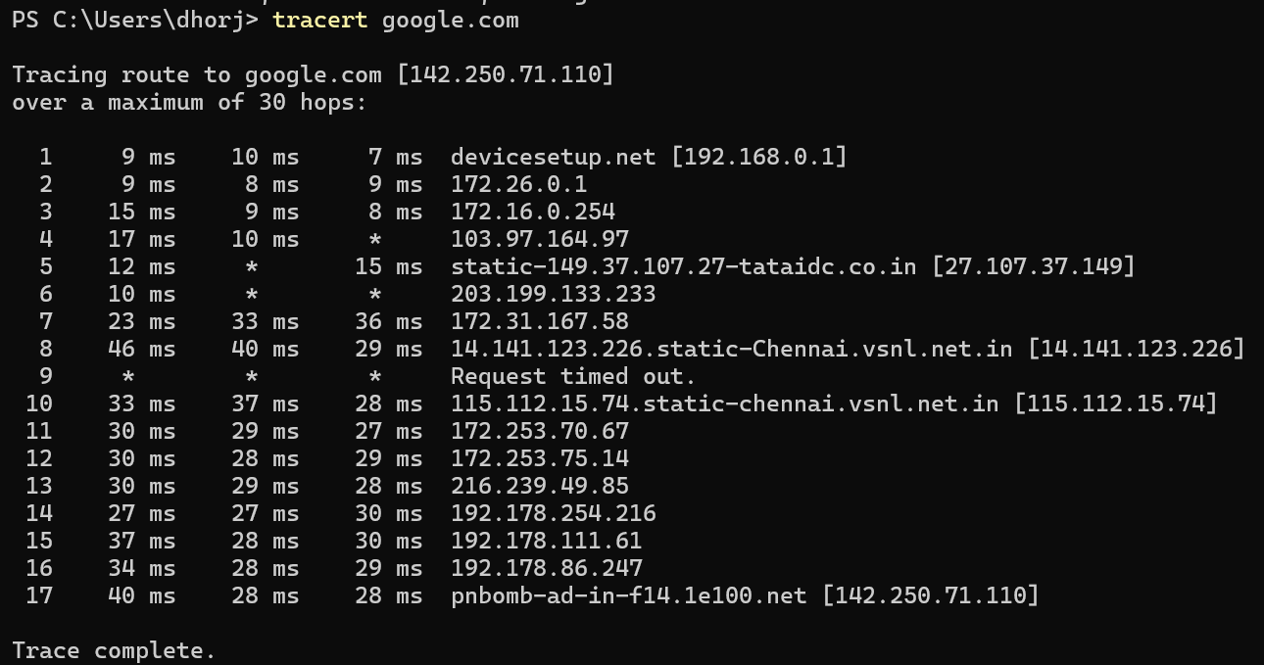
- NETSTAT : A command used to display active network connections and listening ports on the computer.
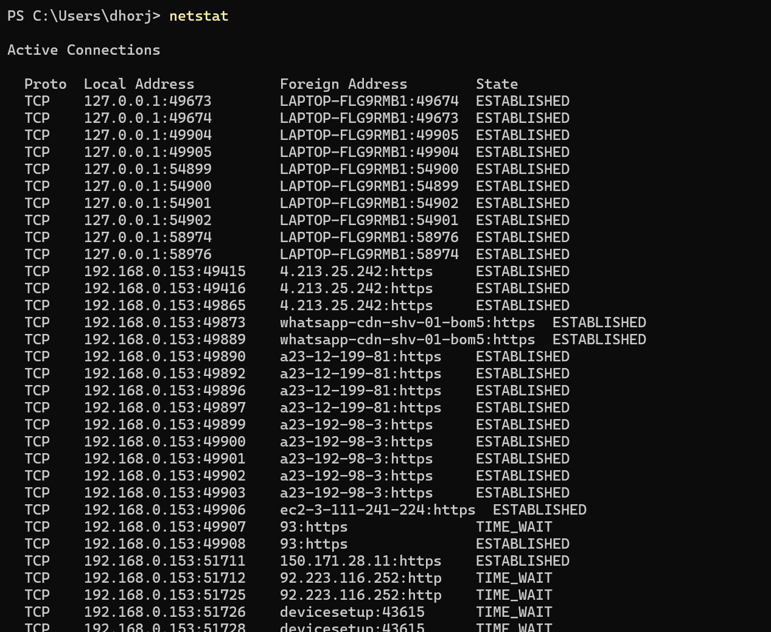

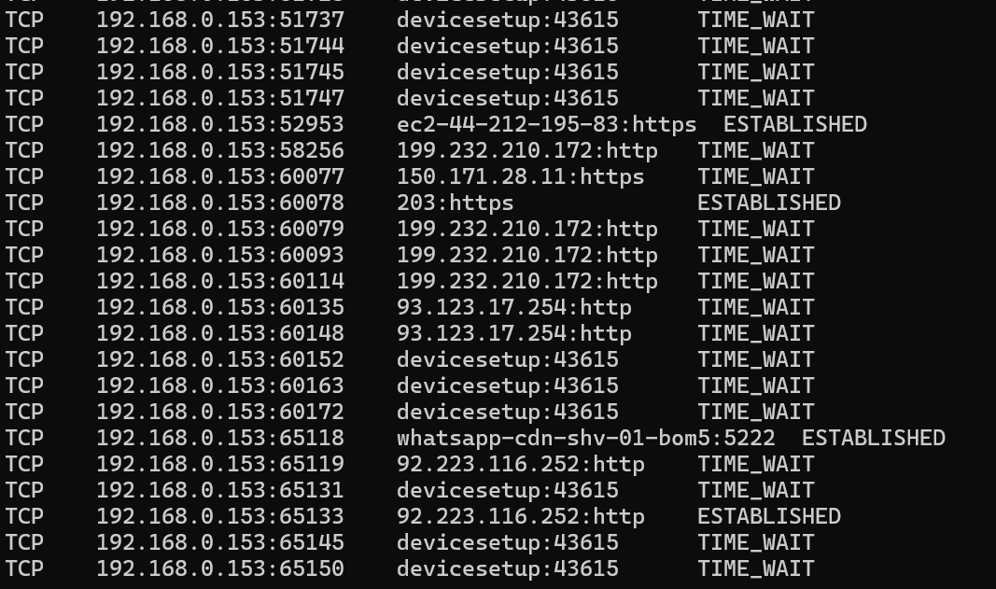

ARP :
A command used to view or modify the ARP table that maps IP addresses to MAC addresses.
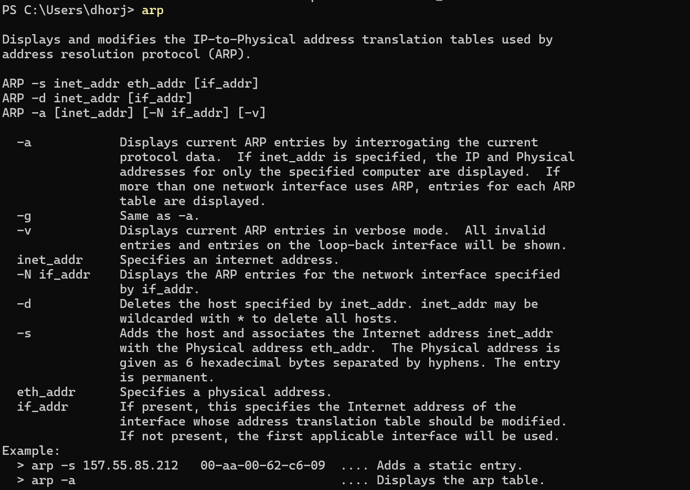
ARP -a :
Displays all current IP-to-MAC address mappings in the ARP table.
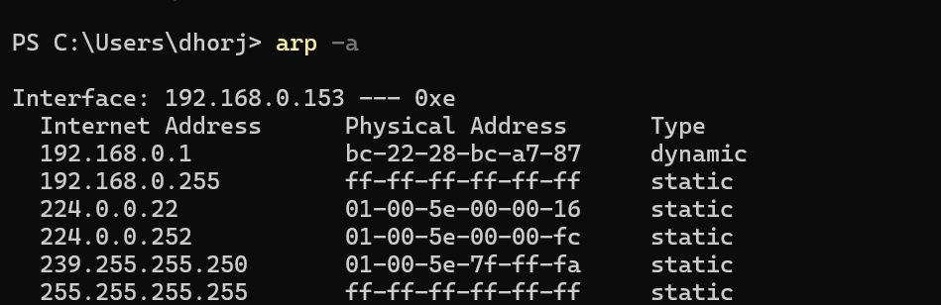
ARP -g :
Same as ARP -a, shows the ARP table entries.
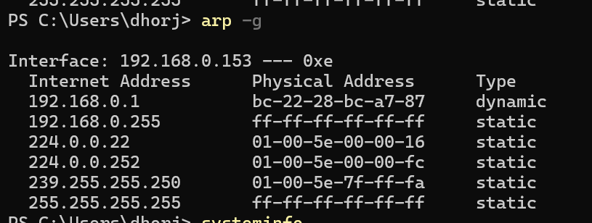

- SYSTEMINFO : A command used to display detailed information about the computer’s hardware and operating system.
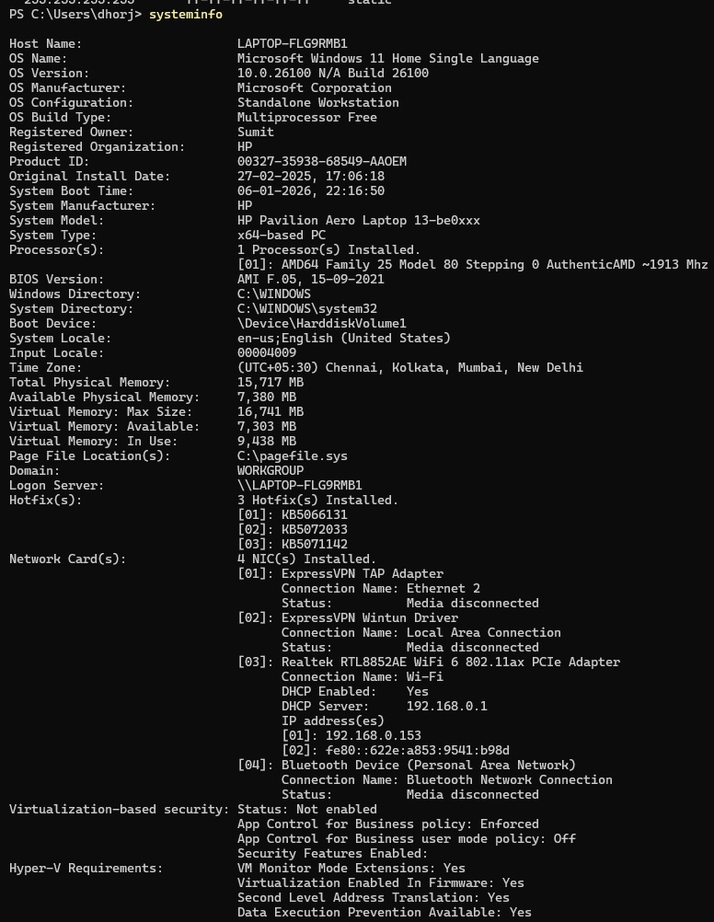

- ROUTES : A command used to display or modify the routing table of the computer.
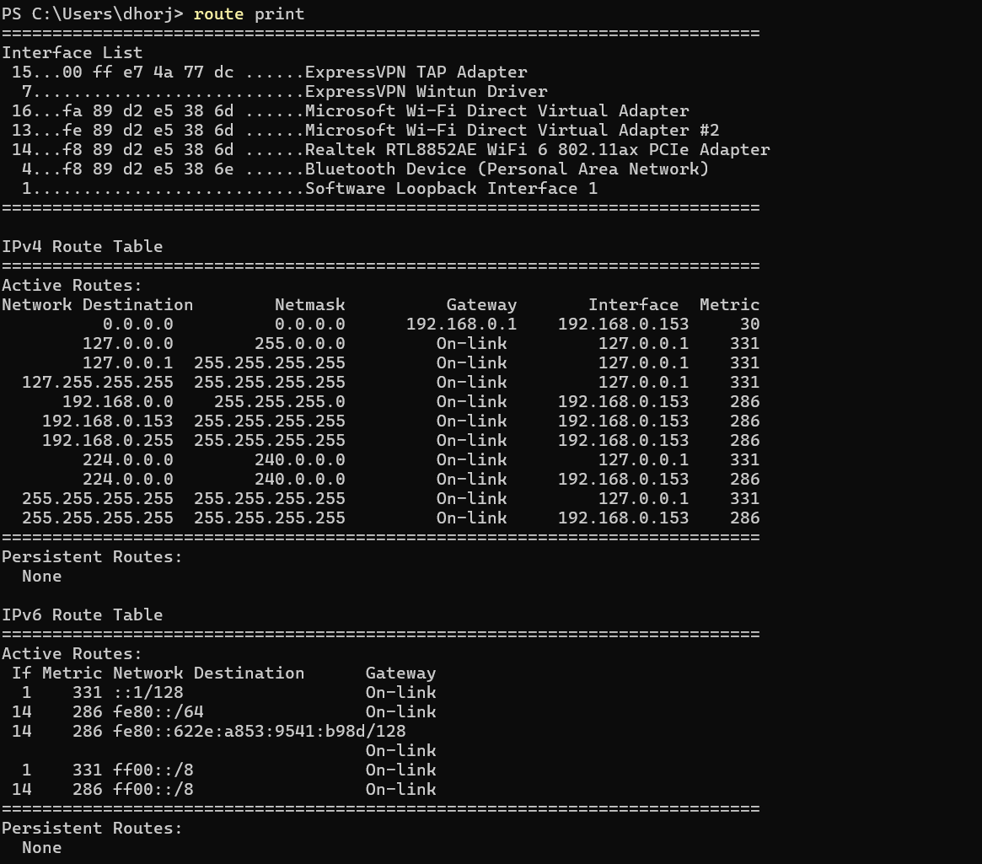

- NETSH : A command used to configure and manage network settings of the computer.
